The commodification of Interactive Digital Installations
Daniel Potes

Interactive installation art has caused collectors and curators trouble from the very beginning. How do you store an Interactive performance? How can a digitally interactive experience be sold? Is there more value in the objects or the experience? The solution to these problems seems to have been commodification. This paper, using the early work of the Experiments in Art and Technology(E.A.T), alongside the contemporary work of teamLab, will argue that Interactive installations have evolved to behave more and more like commodities.

To begin, the terms used throughout this paper must be defined. An interactive digital installation combines several already difficult terms. An Interactive work of art, according to Ryszard Kluszczynski consists less of a specific completed piece of art, more so an experience or “event”. The interactive artist must create an interface with which viewer interactivity “brings life to an artwork-event”. For our purposes, an Interactive Installation then, is an installation created to be interacted with by viewers or participants of the “event”. As Kluszczynski says, the “artist does not make a final, completed piece of art, instead produces an area of activity”, this area of activity is the installation, whether that looks like E.A.T’s 1970 Pepsi Pavilion at the Osaka World's Fair (Figure 3), or Team lab’s Digital Light Canvas at Marina Bay Sands resort (Figure 2).
But what makes an interactive installation digital? A digital Artwork can be defined as a work that is generated through the use of digital inputs, usually through a computing agent, according to Lev Manovich, digital art and “new media” are works that use “digital computer technology for distribution and exhibition”. While some of the effects that E.A.T utilized were technically analog, the creation of the greater “artwork-event” using advanced technology gave their work a digital basis. For the purpose of this paper we will be considering E.A.T’s work as Interactive Digital Installations and Performances.
Finally, our use of the terms “commodification” and “commodities” both have to be defined for our purposes. According to Marxism a commodity is an “external object” which “possesses a double form” that is made up of its natural form and its value form. A commodity is valued by both it’s material, and the labor expended to create it. Commodification on the other hand, is the transition of a “private and public realms” to the “logic of capitalism”, a logic which enforces a system based on monetary value.

For both E.A.T and teamLab, the technique utilized isn’t in the creation of a completed piece, but rather, the use of advanced technology to create Interactive spaces. By looking at E.A.T and their non-profit revenue system as well as where their work was displayed and if it was sold, and comparing that to teamLab and their equivalent systems, we can begin to understand the evolutionary route the collection and sale of digital interactive installations has taken.

When discussing the commodification of interactive digital installation, we are discussing the reduction of the installation to a purely monetary value. Instead of considering the artwork for the sake of the work, the event, and its history, the artwork is viewed by collectors, curators, and potential clients, even the artists themselves, as a commodity or “product” (Figure 5) , an object that will bring in more money.

First we must take note as to an important historical factor in the commodification of art, Marcel Duchamp. Having his “readymades” come to popularity in the early 19th century, set the stage for the shifting of the entire division of artistic labor, which led to the systems in place for the buying and selling of art to start to change. According to Boris Groys, Duchamp’s creation of his readymade installations changed the entire dichotomy of making and displaying art. While Duchamp’s work influenced the commodifiable nature of installation artwork, it doesn’t compare well to the interactive work of both E.A.T and teamLab.

E.A.T was founded in 1966 as a collaboration between Billy Kluver, Robert Rauschenberg, Fred Waldhauer, and Robert Whitman. From the very beginning, this collective was focused almost exclusively on the creation and maintenance of collaborative relationships between artist and engineers. A Non-Profit, E.A.T’s finances were based entirely on fundraising donations, wealthy backers, and corporate sponsors. Because of the group’s immense popularity, by 1969 they had over 2000 artist members and 2000 engineer members with over 15 different local E.A.T. groups being formed. This huge popularity allowed for an increased revenue stream from international fundraising sources
Historically, E.A.T worked directly with governments both Local and National in order to ensure funding and permissions to create their work. They also actively fund-raised through a variety of means, from televising lectures about upcoming exhibits(Figure 4), to submitting in depth research and funding proposals to different groups, such as the Tamblyn & Brown Fundraising Feasibility Study. They did however have their share of massive corporate sponsors. The most notable of course being that of Pepsi’s sponsoring of the Pepsi Pavilion for the 1970 World’s Fair.
The Pepsi Pavilion is a great example of a non-permanent Interactive Installation which was not purchased, could not be collected, and even in terms of their corporate sponsor, was not the most commodifiable work. By taking a look at this work and then comparing it to some of the comparable works be teamLab, we can see some of the shifts towards commodification. The Pepsi Pavilion (Figure 4) was designed as a collaborative effort between the coordinators, Robert Breer and Billy Kluver, the artists Forrest Myers, Robert Whitman, and David Tudor, and finally, the labor of 63 engineers and scientists.
This pavilion was made up of different custom designed spaces and rooms meant to showcase a series of different architectural, technological, and acoustic features. The outside of the pavilion had an installation designed by Fujiko Nakaya in association with an American physicist. This installation shrouded the structure in a fog generated by a custom artificial fog machine. As discussed previously, in this situation, the artist did not design a completed, work, but rather created an effect that changed the way the visitors could visually interact with the pavilion, introducing an interactive effect before they ever even enter.
In comparison to the E.A.T, teamLab has an incredibly different history and financial system.. One of the first large-scale, successful Digital Art Collectives and Businesses, teamLab uses the income from corporate commissions to fund the research and development of future installations and experiments. For instance, one of the-small scale installations that has become more of a product than a Digital Art Installation, is their piece Camellia and Butterflies for Eternity(Figure 1). Permanently installed in the Wedding Venue Chinzanso, the installation is available for purchase for their potential clientele for a price of $1150 per use.

Camellia and Butterflies for Eternity is an example of what teamLab refers to as “products”. Installations, created and designed for commodification. teamLab doesn’t just commodify for the sake money, their goal is “Transcending Boundaries”, using sophisticated new technologies. By immersing audiences in a totally immersive Interactive “artwork-event”, they hope to facilitate “collective discovery” and “collective creation”. teamLab has channelled their work into four distinct but related categories, “Art”, “Products”, “Other” and “Lab”. The system put in place allows for their R&D projects to be utilized as products to fun larger un-commissioned pieces.
teamLab has lately been working on a series of much Larger “artwork events” to be housed on two floors of the Mori Building Digital Art Museum. Titled “Borderless”, this seamless multi-installation experience is meant to have no disconnection between spaces. Considered by teamLab as a “single world”, this 10,000 square meter multi-space museum/permanent exhibit gets rid of the boundaries between the installations in order to “Fully immerse visitors in this world and break down the borders between each visitor.”

This is just one example of the shift to permanent installation exhibitions which has allowed installation artists, especially teamLab, to commodify an otherwise non-commodifiable product. Before they began actively utilizing corporate spaces and permanent museum and gallery exhibits, teamLab had been bringing their installations with them, not selling so much as renting access to their installations. This came with its own issues. Most importantly this meant that teamLab had to send a figure of authority to follow each installation, oversee the installation process and the breakdown of it, and help safely escort the parts home.

This caused issues from technical problems due to damage accrued through travel, to human-based errors due to the authority figure’s exhaustion.During one of his lectures at Pratt institute, Takashi Kudo one of teamLab’s designers, mentioned a story of when one of his team members ended up falling asleep in the gallery after installing one of their early projects. This sleeping member of the team ended up being treated like a part of the installation and ignored. While in this instance everything worked out well, there were far more problematic issues to be handled as part of this this rental process. A process which they still continue, but have slowly begun to shift away from.

teamLab has recently begun focusing more on corporate clients and commissions in an effort to increase their reach, their finances, and their impact on the Fine Arts/ Digital Arts World. Because they are so deeply influenced by the concept of “Play”, “Creativity”, and “Exploration”, teamLab manages to make digital Installation art a commodity, while also increasing the accessibility to include everyone from young children to the elderly. teamLab happens to be lucky enough to have a huge audience for their digital art installations.
Because of their fame throughout Asia, and their continued explorations of fun, accessible interactive installations, teamLab has managed to accrue a huge selection of commissions from small businesses who want to make an impact on prospective clients. An example is “An Office Where Animals Live.” This “Product” is sold to businesses who want to instill a sense of exploration, fun, and play into their office spaces. It does this by using projection mapped generated animals to guide visitors to the correct meeting space within the office building. Just like the E.A.T teamLab interfaces Interactive Installations with architectural design to truly craft the “artwork-event” and space. Unlike E.A.T however, teamLab’s installation is a product to be sold to corporate clients with an expectation to get a return on investment.
teamLab also creates monumental commissioned installations for large corporate clients. These are usually done in large public sections that the corporate client owns or controls. One such example is their permanent installation in Marina Bay Sands titled Digital Light Canvas(Figure 2). These larger permanent and semi-permanent installations/exhibitions allow for not only the funds to create more and more installations, but also allows for more defined experimentation with more permanent technical solutions, a topic that most digital artists rarely think about.

This August, when teamLab opens Borderless at the Mori Building Digital Arts Museum,” it will be the culmination of teamLab’s system of selling, and having their installations collected and financing further research.. Built out of the designs for previous installations, both permanent and non-permanent, this Museum is only possible because teamLab looks at their work differently. Unlike E.A.T, teamLab has built an incredibly profitable business in the commodification of interactive installations, the literal creation of products.

Instead of viewing a digital installation as a one-off art piece that is only to be created once and stored either in a single location or shared with several institutions, teamLab creates installation systems that can be recreated over and over again in order to allow the group to show the same work in multiple different galleries and locations at the same time. E.A.T and teamLab may only be two collectives interested in the creation of large scale interactive digital installations and “artwork events”, but they both represented a huge number of cutting edge interactive digital artists, engineers and programmers. Not only does the shift from E.A.T’s nonprofit system to teamLab’s “product” system showcase the evolution of the commodification and commodifiable nature of interactive digital installations, it is my belief that it also shows a global shift in the wider commodification of art as a whole.

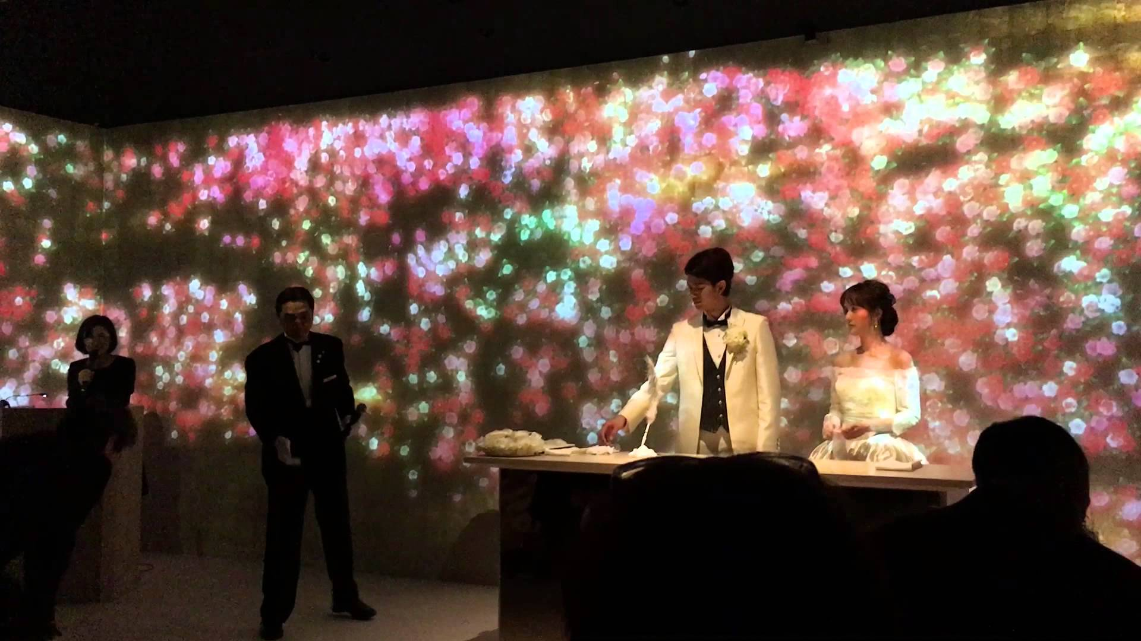
Figure 1. - NANO・UNIVERSE LIBRARY, Camellia and Butterflies for Eternity, Youtube Video Still, Youtube, https://www.youtube.com/watch?v=0ycDONIA6Sk

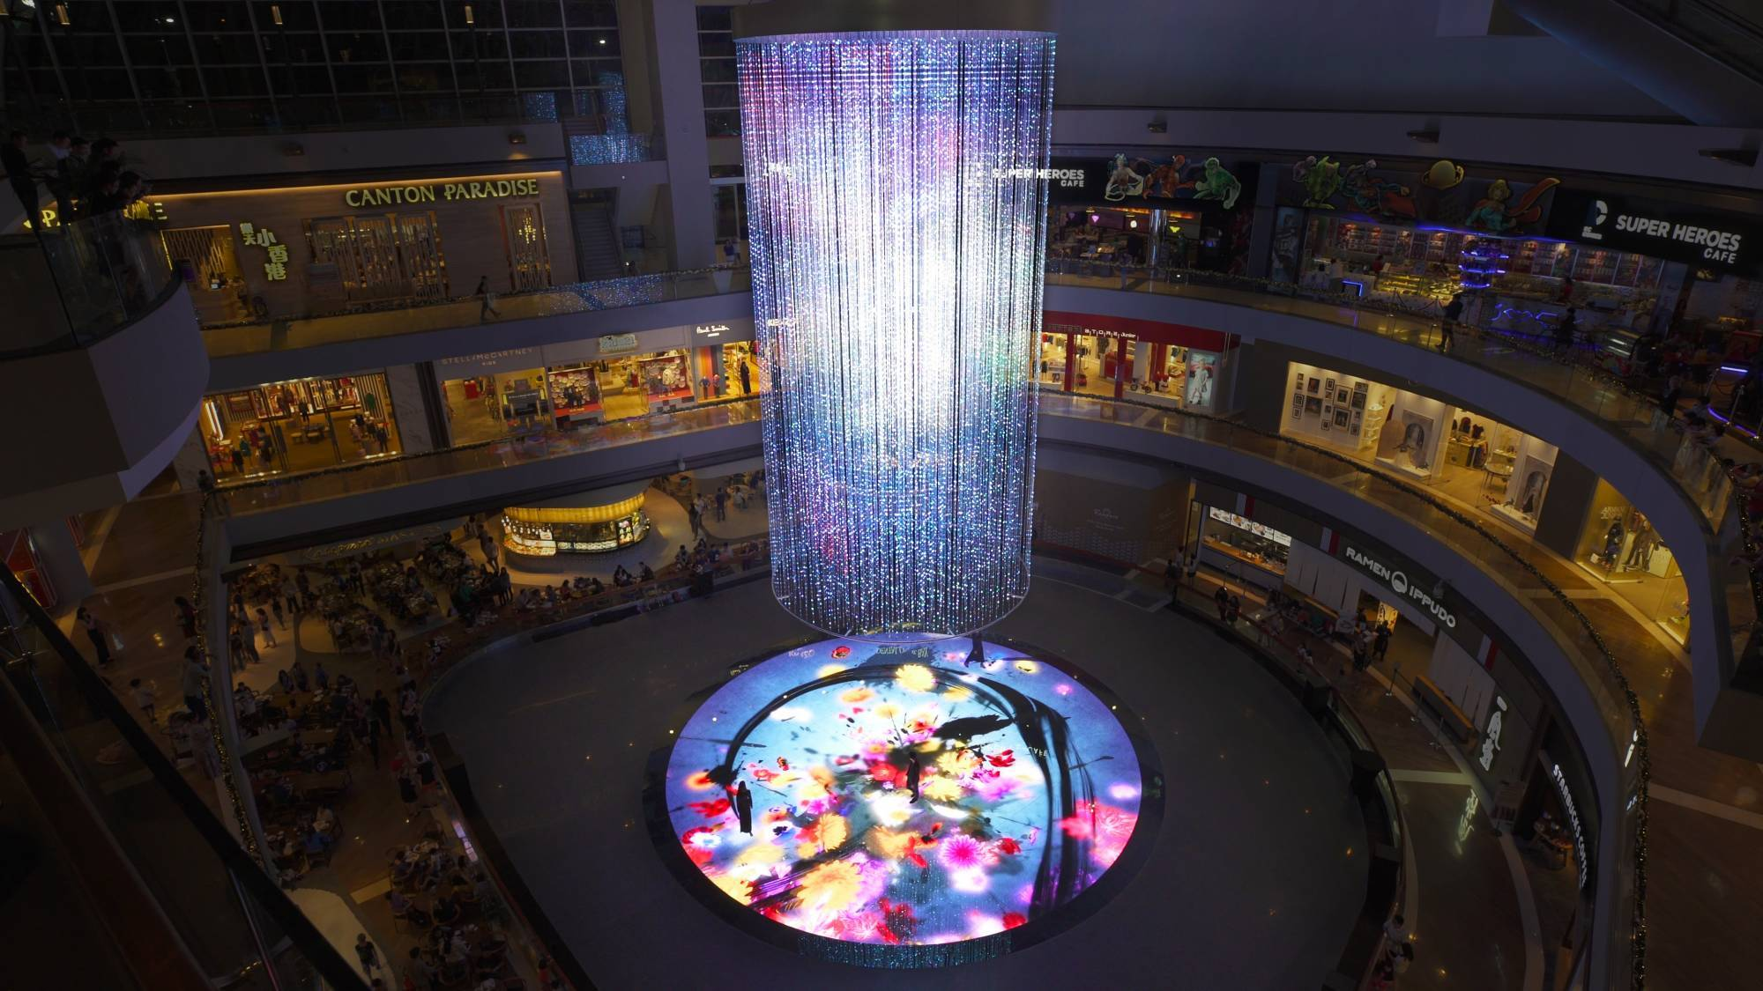
Figure 2. teamLab, Digital Light Canvas, Interactive Projection, teamLab.art,
https://www.teamLab.art/e/digitallightcanvas/

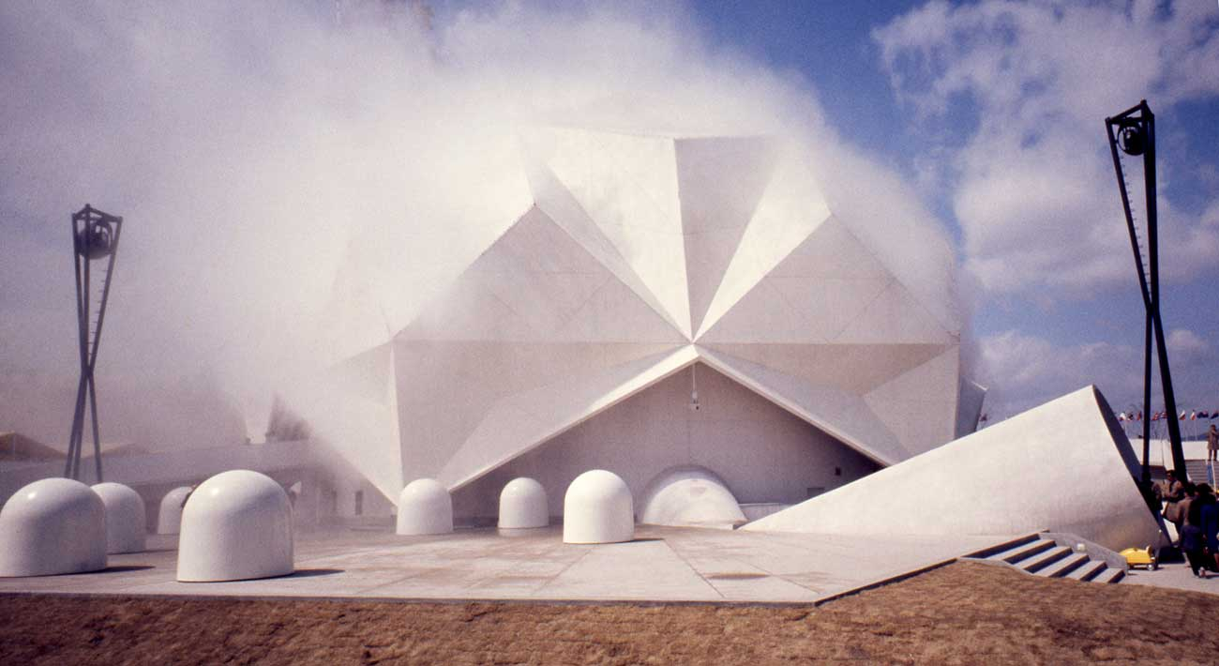
Figure 3. E.A.T 1970 Pepsi Pavilion Osaka World’s Fair, pavilion exterior view, medienkunstnetz.de, http://www.medienkunstnetz.de/works/pepsi-pavillon/images/2/?desc=full

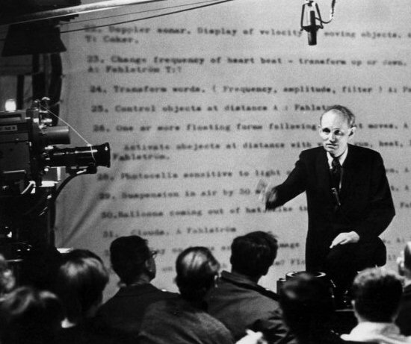
Figure 4. Photographer Unknown, Billy Kluver lectures in a Toronto television studio 1967, Photography, Fondation-langlois.org , http://www.fondation-langlois.org/html/e/page.php?NumPage=394

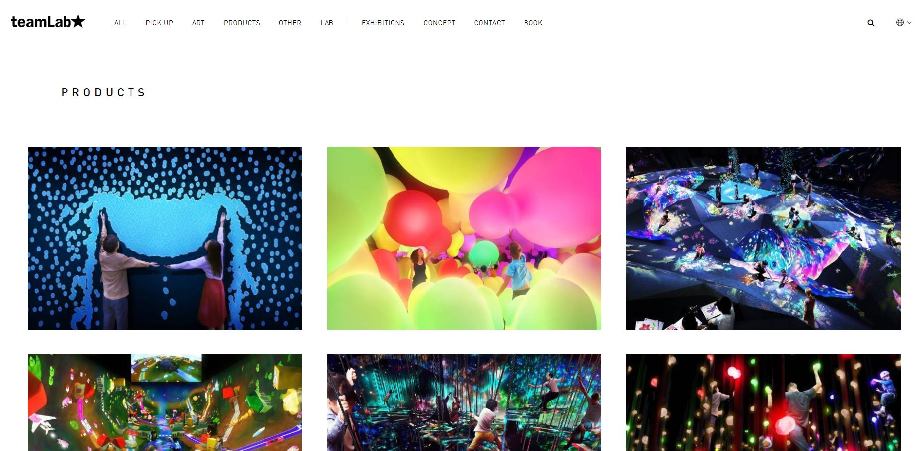
Figure 5. teamLab Product Page, https://www.teamLab.art/products/

Bibliography

RyszardW. Kluszczynski (2010) Strategies of interactive art, Journal of
Aesthetics & Culture, 2:1, 5525, DOI:
10.3402/jac.v2i0.5525
Lev Manovich, “New Media from Borges to html” in The New Media Reader, pg. 10, http://manovich.net/content/04-projects/033-new-media-from-borges-to-html/30_article_2001.pdf.

Felluga, Dino “Terms Used by Marxism”, Purdue U, https://www.cla.purdue.edu/english/theory/marxism/terms/termsmainframe.html.

Getty Special Collections, “Experiments in Art and Technology records, 1966-1993”, Box 122, 1-26. http://archives2.getty.edu:8082/xtf/view?docId=ead/940003/940003.xml;chunk.id=aspace_ref758_56c;brand=default

Boris Groys, “Politics of Installation,” Eflux Journal, Journal #02 - January 2009, http://www.e-flux.com/journal/02/68504/politics-of-installation/ .

Billy Klüver, “E.A.T - Archive of published documents Forward”, The Daniel Langlois Foundation for Art Science and Technology, http://www.fondation-langlois.org/html/e/page.php?NumPage=306 .

Experiments in Art and Technology, “Experiment in Art and Technology records”, Getty Research Institute Special Collections. http://primo.getty.edu/primo_library/libweb/action/dlDisplay.do?vid=GRI&afterPDS=true&institution=GETTY&docId=GETTY_ALMA21123876310001551

Getty Special Collections, “Experiments in Art and Technology records, 1966-1993”, Box 131. http://archives2.getty.edu:8082/xtf/view?docId=ead/940003/940003.xml;chunk.id=aspace_ref758_56c;brand=default

Sebastian Schumacher, “All You Can E.A.T. The 1970 Pepsi Pavilion in Osaka”, 14/Jul 2014, http://www.uncubemagazine.com/blog/13753251.

Richard L. Lewis, Susan Ingalls Lewis, “The Power of Art Revised, A global Art World with a Rich History” (Cengage Learning, 2009), pg 483.

FashionSnap, チームラボがブライダル業界で初コラボ 椿や蝶が舞う幻想的な人前式を演出, 7/07/2016, https://www.fashionsnap.com/article/2016-03-07/teamLab-wedding/

Images

NANO・UNIVERSE LIBRARY, Camellia and Butterflies 人前式 ~1~, Mar 14, 2016, Youtube, https://www.youtube.com/watch?v=0ycDONIA6Sk

E.A.T, 1970 Pepsi Pavilion Osaka World’s Fair, 1970, medienkunstnetz.de, http://www.medienkunstnetz.de/works/pepsi-pavillon/images/2/?desc=full

Photographer Unknown, Billy Kluver lectures in a Toronto television studio 1967, 1967, Fondation-langlois.org , http://www.fondation-langlois.org/html/e/page.php?NumPage=394
teamLab, teamLab Product Page, 4/31/18, teamLab.art, https://www.teamLab.art/products/

? Both analog and digital.
? Ryszard Kluszczynski, “Strategies of interactive art,” Journal of Aesthetics & Culture, https://doi.org/10.3402/jac.v2i0.5525 .
? Lev Manovich, “New Media from Borges to html”, pg. 10, http://manovich.net/content/04-projects/033-new-media-from-borges-to-html/30_article_2001.pdf.
? Felluga, Dino “Terms Used by Marxism”, Purdue U, https://www.cla.purdue.edu/english/theory/marxism/terms/termsmainframe.html.
? Getty Special Collections, “Experiments in Art and Technology records, 1966-1993”, Box 122, 1-26.
? Whether in the form of foot traffic, or social awareness through publication, or in the literally amount earned from the sale of the work.
? Boris Groys, “Politics of Installation,” Eflux Journal, http://www.e-flux.com/journal/02/68504/politics-of-installation/.
? Billy Klüver, “E.A.T - Archive of published documents Forward”, The Daniel Langlois Foundation for Art Science and Technology, http://www.fondation-langlois.org/html/e/page.php?NumPage=306.
? Experiments in Art and Technology, “Experiment in Art and Technology records”, Getty Research Institute Special Collections.
? Getty Special Collections, “Experiments in Art and Technology records, 1966-1993”, Box 131.
? Sebastian Schumacher, All You Can E.A.T. The 1970 Pepsi Pavilion in Osaka, 14/Jul 2014, http://www.uncubemagazine.com/blog/13753251.
? FashionSnap, チームラボがブライダル業界で初コラボ 椿や蝶が舞う幻想的な人前式を演出, https://www.fashionsnap.com/article/2016-03-07/teamLab-wedding/ , 7/07/2016.
? See Figure 5.
? Richard L. Lewis, Susan Ingalls Lewis, “The Power of Art Revised, A global Art World with a Rich History” (Cengage Learning, 2009), pg 483.
? Mostly commissioned work such as the “Serpenti Sparkle” (https://www.teamLab.art/w/serpenti-sparkle/), “Bacardi Jungle Bar”(https://www.teamLab.art/w/bacardi-junglebar/), “Light Chords”(https://www.teamLab.art/w/lightchords/), Etc...
? teamLab, “Mori Building Digital Art Museum teamLab Borderless”, https://borderless.teamLab.art/ .
? (Figure 5)

